|  |
| --- |
| , RD Dep. |
| **Oracle SQL Basics** |

|  |  |  |  |  |  |
| --- | --- | --- | --- | --- | --- |
| REVISION HISTORY | | | | | |
| Ver. | Description of Change | Author | Date | Approved | |
| Name | Effective Date |
| 1.0 | Initial Version | Siarhei Kandrashevich | 15-Jan-2014 |  |  |
|  |  |  |  |  |  |

Contents

1. Task 1. JOIN 3

2. Task 2. HAVING 4

3. Task 3. Join * 4

# Task 1. JOIN

Write query which will show us the information about average salary each departments together with the names, salaries, and jobs of the employees working in each department;

Warning: This is not full result.

# Task 2. HAVING

Create query which show us the following result for the highest and the lowest number of employees in departments.

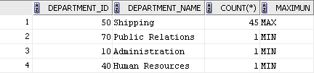

# Task 3. Join *

Create the query which will shows information about manager and their subordinate.

The result must contain the following list of records:

Manager Name,

Manager Salary,

Count of subordinate,

Average salary of subordinates,

Difference in percentages between Manager Salary and him subordinates.

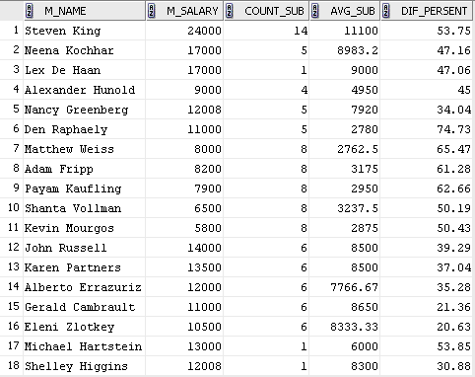

Note! You must write all results in one file **LastName_FirstName_task1.**odt (doc, docx). The mail must have the subject **'Oracle SQL Introduction'**. E-mail: Siarhei_kandrashevich@epam.com